HOW IT WORKS (AA Big Book p.58-59)
My name is <First names only>, and I'm a Sex Addict.

Rarely have we seen a person fail who has thoroughly followed our path.

Our stories disclose in a general way what we used to be like, what happened, and what we are like now. If you have decided you want what we have and are willing to go to any length to get it – then you are ready to take certain steps.

At some of these we balked. We thought we could find an easier, softer way. But we could not. With all the earnestness at our command, we beg of you to be fearless and thorough from the very start. Some of us have tried to hold on to our old ideas and the result was nil until we let go absolutely.

Remember that we deal with sexual addiction – cunning, baffling, powerful! Without help it is too much for us. But there is One who has all power - that One is God. May you find God now!

Half measures availed us nothing. We stood at the turning point. We asked God's protection and care with complete abandon.

THE 12 STEPS (SAA Green Book p.20)
My name is <First names only>, and I'm a Sex Addict.

These steps are our program. They contain a depth that we could hardly have guessed when we started.

- We admitted we were powerless over addictive sexual behaviour - that our lives had become unmanageable.
- Came to believe that a power greater than ourselves could restore us to sanity.
- Made a decision to turn our will and our lives over to the care of God, as we understood God.
- Made a fearless and searching moral inventory of ourselves.
- Admitted to God, to ourselves, and to another human being the exact nature of our wrongs.
- Were entirely ready to have God remove all these defects of character.
- Humbly asked God to remove all our shortcomings.
- Made a list of all persons we had harmed and became willing to make amends to them all.
- Made direct amends to all such people wherever possible, except when to do so would injure them or others.
- Continued to take personal inventory, and when we were wrong promptly admitted it.
- Sought through prayer and meditation to improve our conscious contact with God as we understood God, praying only for knowledge of His will for us and the power to carry that out.
- Having had a spiritual awakening as a result of these steps, we tried to carry this message to other sex addicts and to practice these principles in all areas of our lives.

Many of us exclaimed, "What an order! I can't go through with it." Do not be discouraged. No one among us has been able to maintain anything like perfect adherence to these principles. We are not saints. The point is that we are willing to grow along spiritual lines. The principles we have set down are guides to progress. We claim spiritual progress rather than spiritual perfection.

NEWCOMERS’ WELCOME
My name is <First names only>, and I'm a Sex Addict.

Dear < Newcomers’ names >

Welcome to S.A.A.. When we came to our first meeting many of us were having a variety of feelings. We were relieved to have found a place where our pain and despair might be understood. We were angry that we had to get help and couldn’t manage this part of our lives. We felt lonely and were ashamed of our sexual history. We had secrets that we were reluctant to share. We were distrustful, guarded and frightened. We had been abused and we had abused others. We were sex addicts and needed help.

The Programme of S.A.A. is patterned after the Twelve Step Programme of Alcoholics Anonymous. Here we learn a new way of living. We learn, at our own pace, to experience intimacy and sharing with others in a healthy way. We learn to trust; to express our feelings; to ask for our needs to be met; to say no when no is appropriate; and to stay around when all we want to do is run. Here no one shames us for what we have done or are still doing.
Here we have a safe harbour within which to heal, and for that we are grateful.

The only requirement for membership in S.A.A. is a desire to stop compulsive sexual behaviours. It is a programme of progress, not perfection. If you are willing to be honest and have a desire to have and maintain healthy relationships, then you are in the right place.

It is suggested that you attend at least six meetings before you decide whether the programme is for you. At your first meeting we encourage you to talk to others and exchange telephone numbers with those you relate to. We also suggest that you select a temporary sponsor to assist you in learning the basics. The selection process is easy: all you do is ask someone you relate to (to whom you are not sexually attracted) if they would be willing to be your temporary sponsor until you learn your way around. At a later date, after you have got to know us better, we suggest you choose a permanent sponsor.

Although anonymity is a core tradition on which the programme depends, you should be aware that some people may decide after careful thought to report certain disclosures to the authorities.

In addition to attending meetings and talking with others we suggest you read our primary text Sex Addicts Anonymous (The green Book) , S.A.A. pamphlets available via Intergroup, saauk.info and saa-recovery.org, Alcoholics Anonymous (The Big Book) and other appropriate recovery literature.

We are happy that you are here, for it is the newcomer that keeps S.A.A. alive and well. We encourage you to take it ONE DAY AT A TIME, BE GENTLE WITH YOURSELF, and KEEP COMING BACK.

JUST FOR TODAY
My name is <First names only>, and I'm a Sex Addict.

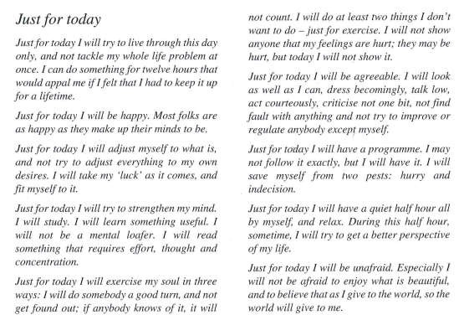
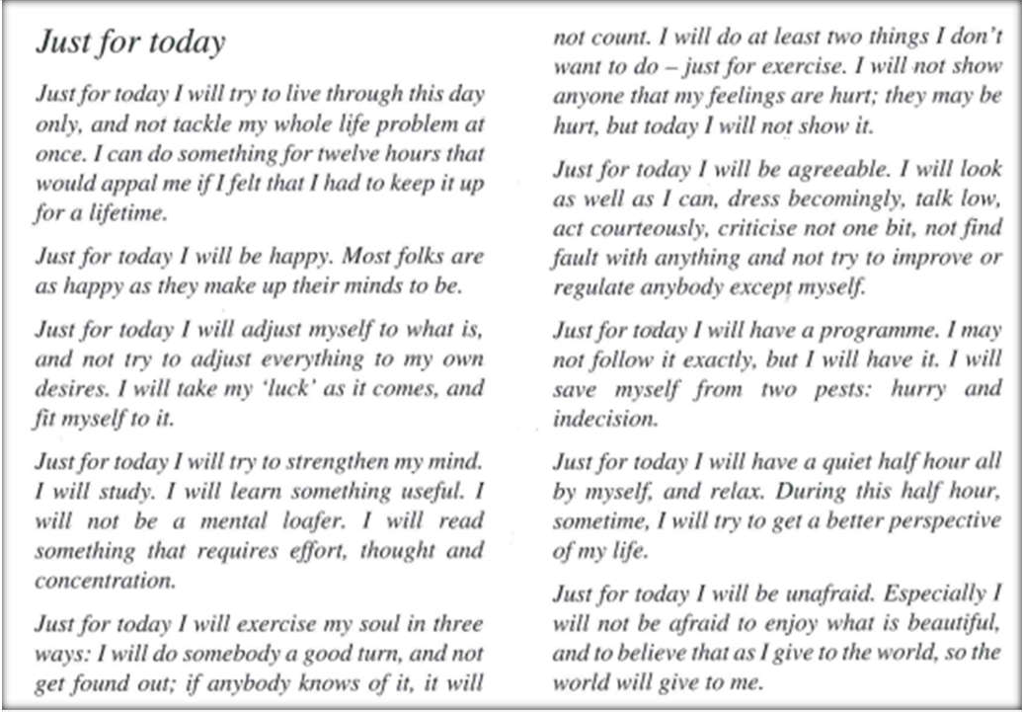

SERENITY PRAYER

God grant me the serenity

To accept the things I cannot change
The courage to change the things I can And the wisdom to know the difference

