UK Tuesday Morning Telemeeting of Sex Addicts Anonymous
This meeting is registered with the UK Intergroup with the following details:
- Meeting type: Closed, Mixed, Topic/Focus
  - First week – Tools of the program
  - Second week – Main Share - Personal Story of Strength Hope and Recovery
  - Third week – Step reading of the month
  - Fourth week - The Tradition of the Month
  - Fifth week - Readings from Answers in the Heart and Voices of Recovery
- Day: Tuesdays
- Time: 9:30-10.30am
- ISO Group Code:
- Email Contact : GSR - UK.Tuesday.Morning@gmail.com
Secretary - uk.tuesday.secretary@gmail.com
Newcomer Servant - uk.tuesday.newcomer@gmail.com
- Telephone Contact: UK dial 0330 606 0403 Access code 839518#

A note for Secretaries:
This initial structure for the UK Tuesday Morning Meeting of Sex Addicts Anonymous has been prepared for review and agreement by Group Conscience.
Each group should be autonomous except in matters affecting other groups or S.A.A. as a whole. Within this constraint the structure and content of this meeting and meeting script can be changed at any time by a Group Conscience Meeting given two weeks' notice.
Date of Group Conscience. | Amendments
21/05/2016 | 1st SAA Meeting. Script agreed by group conscience.
05/05/2016 | Minor amendments and correction of Typo’s.
16/08/2016 | Week 3 & week 4 focus, which step, or tradition is read in each month clarified.
08/11/2016 | Correction of Typo’s in the script.
11/04/2016 | Change in weekly focus  - Introduction of Main share week 2  - Open chare topic moved to week 5  Secretary – 6-month duration each may & November  Script wording amended - Sponsorship and sharing of Numbers in fellowship.
20/3/18 | - Email access to script available in Gmail account uk.tuesday.morning@gmail.com – GSR Has the password for this account  - Agree to give 2 weeks’ notice to group of changes to meeting script.  - Service position:  - GSR  - Chair Finder  - Agreed to keep the newcomer’s letter as it stands, unaltered.  - Agree service positions to have a minimum requirement of 3 months sobriety
11/12/18 | - Agreed script adjustment – input section of text highlighting that secretary may intervene.
16/12/19 | - Changed “men and women” to “people”  - Added section regarding being able to see contact numbers through telemeeting portal  - Added reference to tradition 6 regarding use of freeconferencecall.com  - Changed from volunteer to secretary reading ‘The Letter to Newcomers’  - Removed duplicate sentence regarding calling in early to do service  - Added in mention of newcomers in group introductions  - Updated the dial-in information
25/02/20 | - Changed information about obtaining telephone numbers to giving out numbers for intergroup and women’s number. Added to main script and newcomer’s letter.
21/04/20 | - Changed where numbers for contact are read out to highlight Newcomer Servant as contact for outreach and sponsorship.  - Added section in script for secretary to read to intervene when members cannot be heard.  - Changed script to have saauk.info as the only website, rather than reading out multiple different websites.  - Telephone number updated.
08/12/20 | - Amended week five focus to readings from Answers in the Heart and Voices of Recovery daily reflections  - Amended Tools of Recovery numbers to reflect updated pamphlet

MEETING SCRIPT
WELCOME
(+0.00) Secretary: Good morning. My Name is <Your Name> And I am a sex addict.
I will be your script servant for today’s meeting.
DISCLAIMER

Just to make members aware before we start the meeting, that the GSR can see participant’s telephone numbers using the online meeting portal. If members wish to preserve their anonymity, if you are in the UK, please drop off the call and re dial using the 141 prefix before the meeting telephone number. However it is only the GSR that can see your number no other participants can see this information. In order to facilitate this meeting we use freeconferencecall.com, but this group does not endorse, finance, or lend the SAA name to any related facility or outside enterprise.
We would like to remind members who are not speaking to mute their phones directly or by pressing star six, especially if they are in a noisy environment or using a speakerphone. To unmute press star 6 again.
OPENING
This is the UK Tuesday Morning Tele- Meeting of Sex Addicts Anonymous.
SAA is a fellowship of people who share our experience, strength, and hope with each other so that we may stop our addictive sexual behaviour and help others to recover from sexual addiction. The only requirement for membership is a desire to stop addictive sexual behaviour.
SAA is self-supporting; is not allied to any sect, denomination, politics, organisation, or institution; does not wish to engage in any controversy; neither endorses nor opposes any causes. Our primary purpose is to stay sexually sober and help other sex addicts to achieve sexual sobriety.
Our programme is derived from the Twelve Steps and Twelve Traditions of Alcoholics Anonymous. Although we are not affiliated with AA we are Grateful to AA for this gift.
Anonymity is a core tradition on which the programme depends. Let us make this a Safe Meeting to bring the message of Strength Hope and Recovery, focused on the 12 steps and 12 traditions.

SERENITY PRAYER
Let us now open the meeting with the serenity prayer using the word God as you understand it.
ALL AT WILL: 'God, grant me the serenity to accept the things I cannot change, courage to change the things I can, and wisdom to know the difference.

OUR ADDICTION
(+0.02) Secretary: Please may we have a volunteer to read “Our Addiction”

VOLUNTEER: My name is <First names only>______, and I'm a Sex Addict.
Our addiction (page 3 paragraph 1-2 of SAA green book)Before coming to Sex Addicts Anonymous, many of us never knew that our problem had a name. All we knew that we couldn’t control our sexual behaviour. For us, sex was a consuming way of life. Although the details of our stories were different, our problem was the same. We were addicted to sexual behaviours that we returned to over and over, despite the consequences.
Sex addiction is a disease affecting the mind, body, and spirit. It is progressive with the behaviour and its consequences usually becoming more severe over time. We experience it as a compulsion, which is an urge that is stronger than our will to resist, and as obsession, which is a mental preoccupation with sexual behaviour and fantasies. In SAA, we have come to call our addictive sexual behaviour “acting out”.

THE 12 STEPS
(+0.05) Secretary: Thank you <volunteer’s name> Please may we have a volunteer to read the “The 12 Steps”

VOLUNTEER: My name is <First names only>______, and I'm a Sex Addict.
The 12 Steps (pg 20 SAA green book)
These steps are our program. They contain a depth that we could hardly have guessed when we started.
- We admitted we were powerless over addictive sexual behaviour - that our lives had become unmanageable.
- Came to believe that a power greater than ourselves could restore us to sanity.
- Made a decision to turn our will and our lives over to the care of God, as we understood God.
- Made a fearless and searching moral inventory of ourselves.
- Admitted to God, to ourselves, and to another human being the exact nature of our wrongs.
- Were entirely ready to have God remove all these defects of character.
- Humbly asked God to remove all our shortcomings.
- Made a list of all persons we had harmed and became willing to make amends to them all.
- Made direct amends to all such people wherever possible, except when to do so would injure them or others.
- Continued to take personal inventory, and when we were wrong promptly admitted it.
- Sought through prayer and meditation to improve our conscious contact with God as we understood God, praying only for knowledge of His will for us and the power to carry that out.
- Having had a spiritual awakening as a result of these steps, we tried to carry this message to other sex addicts and to practise these principles in all areas of our lives.

Many of us exclaimed, "What an order! I can't go through with it." Do not be discouraged. No one among us has been able to maintain anything like perfect adherence to these principles. We are not saints. The point is that we are willing to grow along spiritual lines. The principles we have set down are guides to progress. We claim spiritual progress rather than spiritual perfection.

TRADITION OF THE MONTH
(+0.08) Secretary: Thank you <volunteer’s name>

I will now read the tradition of the month, this month being <xxx> of the year , Tradition <xx>
“The tradition of the month, i.e., September = 9th tradition”

- Our common welfare should come first; personal recovery depends upon S.A.A. unity.
- For our group purpose there is but one ultimate authority - a loving God as may be expressed in our group conscience. Our leaders are but trusted servants; they do not govern.
- The only requirement for membership in S.A.A. is a desire to stop addictive sexual behaviour.
- Each group should be autonomous except in matters affecting other groups or S.A.A. as a whole.
- Each group has but one primary purpose - to carry its message to the addict who still suffers.
- Our fellowship ought never to endorse, finance, or lend its name to any related facility or outside enterprise, lest problems of money, property and prestige divert us from our primary purpose.
- Each group ought to be fully self-supporting, declining outside contributions.
- Sex Addicts Anonymous should remain forever non-professional, but our service centres may employ special workers.
- S.A.A. as such, ought never be organised; but we may create service boards or committees directly responsible to those they serve.
- Sex Addicts Anonymous has no opinion on outside issues; hence the S.A.A. name ought never be drawn into public controversy.
- Our public relations policy is based on attraction rather than promotion; we need always maintain personal anonymity at the level of press, radio, TV, and films.
- Anonymity is the spiritual foundation of all our traditions, ever reminding us to place principles before personalities.

REFLECTION
(+0.11) Secretary: Please can we have a few moments silence in which to reflect on why we are here and to think of the still suffering addict.

Sufficient silence for reflection and thinking - usually about 30 seconds.
Thank you.

GROUP INTRODUCTIONS
(+0.12) Secretary:
We now come to Group Introductions in which we each introduce ourselves by our first name only, and General Location. If there are any newcomers, that is anyone for whom this is their first SAA meeting, please introduce yourselves so we can welcome you to the meeting. We would also like to welcome anyone who is new to this particular meeting, we are glad to have you with us today.
Starting with the secretary each member in turn introduces themselves and the rest of the group responds by greeting them by their first name.
This style of introduction and group greeting is used every time a member speaks during the meeting, except when reading.

IF THERE IS A NEWCOMER,
(+0.20) Secretary: Since this is <Newcomer’s name> first meeting I will now read ‘The Letter to Newcomers’.
Dear < Newcomers names >
Welcome to S.A.A. When we came to our first meeting many of us were having a variety of feelings. We were relieved to have found a place where our pain and despair might be understood. We were angry that we had to get help and couldn’t manage this part of our lives. We felt lonely and were ashamed of our sexual history. We had secrets that we were reluctant to share. We were distrustful, guarded, and frightened. We had been abused and we had abused others. We were sex addicts and needed help.
The programme of S.A.A. is patterned after the Twelve Step Programme of Alcoholics Anonymous. Here we learn a new way of living. We learn, at our own pace, to experience intimacy and sharing with others in a healthy way. We learn to trust; to express our feelings; to ask for our needs to be met; to say no when no is appropriate; and to stay around when all we want to do is run. Here no one shames us for what we have done or are still doing. Here we have a safe harbour within which to heal, and for that we are grateful.
The only requirement for membership in S.A.A. is a desire to stop compulsive sexual behaviours. It is a programme of progress, not perfection. If you are willing to be honest and have a desire to have and maintain healthy relationships, then you are in the right place.
It is suggested that you attend at least six meetings before you decide whether the programme is for you. At this meeting we do not share individuals’ numbers. For outreach or sponsorship, we encourage you to stay on the call after the meeting to speak with the Newcomer Servant, alternatively you can email uk.tuesday.newcomer@gmail.com.
We also suggest that you select a temporary sponsor to assist you in learning the basics. The selection process is easy: all you do is ask someone you relate to (to whom you are not sexually attracted) if they would be willing to be your temporary sponsor until you learn your way around. At a later date, after you have got to know us better, we suggest you choose a permanent sponsor.

Although anonymity is a core tradition on which the programme depends, you should be aware that some people may decide after careful thought to report certain disclosures to the authorities.

In addition to attending meetings and talking with others we suggest you read our primary text Sex Addicts Anonymous (The green Book), S.A.A. pamphlets available via Intergroup, saauk.info, Alcoholics Anonymous (The Big Book), and other appropriate recovery literature.
We are happy that you are here, for it is the newcomer that keeps S.A.A. alive and well. We encourage you to take it ONE DAY AT A TIME, BE GENTLE WITH YOURSELF, and KEEP COMING BACK.

FOCUS
(+0.20) Secretary: We now come to the focus of today’s meeting.
This being the <x^{th} week of the month > the focus is:
      - First week - Tools of the program
      - Second week – Main Share - Personal Story of Strength Hope and Recovery
      - Third week – Step reading of the month
      - Fourth week - The Tradition of the Month
      - Fifth week – Daily Reflections from Answers in the Heart and Voices of Recovery
First week – Tools of the Program - See script below.
Second week – Main Share - Personal Story of Strength Hope and Recovery, by < Name >, who will share for 20 minutes. < Name > would you like any time checks (usually 10 minutes and 5 minutes to go)
Third week - Step reading of the month. This month being <xxx> of the year, Step <xx>
- June- Step 1, | - October – Step 5 | - February – Step 9
- July – Step 2 | - November – Step 6 | - March – Step 10
- August. – step 3 | - December – Step 7 | - April – Step 11
- September – step 4 | - January – Step 8 | - May Step 12

Fourth week – Tradition of the Month, this month being <xxx> of the year, Tradition <xx>
- June- Tradition 1, | - October – Tradition 5 | - February – Tradition 9
- July – Tradition 2 | - November – Tradition 6 | - March – Tradition 10
- August. – Tradition 3 | - December – Tradition 7 | - April – Tradition 11
- September – Tradition 4 | - January – Tradition 8 | - May Tradition 12

Fifth week - Daily Reflections from ‘Answers in The Heart’ and ‘Voices of Recovery’

First reading to be read and shared on then halfway through share time, second reading to be read and shared on

First Week Topic
(+0.21) Secretary: Please can we have two volunteers to each select a number between 1 and 50 by which we will choose the tools for today’s readings from the SAA Literature – “Tools of Recovery - A Practical Guide for New Members of SAA”

Tool |  | Page | Tool |  | Page
1 | Eleventh Step Prayer | 44 | 26 | Identify don’t compare | 30
2 | Handling Travel | 36 | 27 | The Twelve Steps (Appendix A) | 44
3 | Outer circle activities | 39 | 28 | Attending meetings | 4
4 | Sponsorship | 2 | 29 | Powerlessness | 21
5 | Easy Does it | 31 | 30 | Service | 40
6 | Literature | 5 | 31 | Prayer | 16
7 | Using the Telephone | 9 | 32 | Meditation | 19
8 | Fellowship | 12 | 33 | Resentments | 22
9 | Being Positive | 38 | 34 | Bookending | 23
10 | Gratitude lists | 22 | 35 | The Twelve Steps | 2
11 | Asking Questions | 33 | 36 | First Step Presentation | 10
12 | Getting some exercise | 40 | 37 | Writing | 20
13 | Rigorous Honesty | 29 | 38 | Getting honest about the middle circle | 8
14 | Outside Resources | 35 | 39 | Friendship | 12
15 | Serenity Prayer  (Appendix C Prayers) | 44 | 40 | Defining God of our understanding | 18
16 | The Three Circles | 6 | 41 | HALT | 24
17 | One day at a time | 11 | 42 | Thinking a Slip all the way through | 27
18 | Changing Old Routines | 13 | 43 | Three Second Rule | 25
19 | Let go & Let God | 18 | 44 | Fears | 21
20 | Looking at Consequences | 26 | 45 | Living through the discomfort of Withdrawal | 14
21 | Letting go of old ideas | 28 | 46 | The 12 traditions (Appendix B) | 43
22 | Progress not perfection | 31 | 47 | Introduction | 1
23 | Live & Let Live | 32 | 48 | One Day At A Time | 11
24 | Feedback | 34 | 49 | Three Second Rule | 25
25 | Three things a day | 36 | 50 | Fears | 21

GENERAL SHARING
(+0.30) Secretary: We now come to General Sharing.
We encourage your share on today’s meeting focus. Please share on your Experience Strength & Hope encountered in recovery and the 12 Steps and 12 Traditions. Please bear in mind tradition five, ‘each group has but one primary purpose - to carry its message to the sex addict who still suffers.
In your sharing, please be sensitive to the safety of others by avoiding overly specific descriptions of acting out behaviours, naming specific places you have acted out in or publications, broadcasts, and services you have used and avoid using slang terms for acting out behaviour.
We do not interrupt each other, and we do not ask questions or engage in discussion, please speak in “I” Statements not “You” statements to avoid sounding like you are giving advice. Be aware that the secretary may intervene in the unlikely event of an inappropriate share.
Although anonymity is a core tradition, you should be aware that some people may decide, after careful thought, to report certain disclosures to the authorities. We use only our first names. Whatever our status or position outside of this group is not an issue here.
Try, if you can, to keep your sharing to within [- Three to Five -] minutes. We do not have to check in if we don't want to. Please be mindful of muting your phone if you are not speaking to avoid interrupting others’ shares, you can mute your phone directly or by pressing star 6, to unmute press star 6 again. Please be aware that the secretary may intervene in the event of background noise or if a sharer cannot be heard.
The time is now <time > and General Sharing will finish at 10:20am. Please introduce yourself if you wish to share. The meeting is now open.
(Optional) In the case of long silences (a minute) announce the following –
I invite anyone who has shared to come in and share further their experience, strength, and hope in order to fulfil the group’s primary purpose.
(Optional) In the case of background noise –
Apologies for interrupting, please can I ask that all fellows check their phones are muted as background noise can be heard on the call.
(Optional) In the case that the person sharing cannot be heard –
Apologies for interrupting, [name of person sharing] your share cannot be heard clearly, can I request that you check your signal and proximity to the microphone to ensure we are able to hear you.
If the issue continues –
[name of person sharing] unfortunately you still cannot be heard clearly, can I suggest that you end your sharing due to this.
END OF SHARING
(+0.50) Secretary: Thank you everyone for your shares.

SEVENTH TRADITION
(+0.50) Secretary: May I remind everyone of the Seventh Tradition, that is, that every S.A.A. group ought to be fully self-supporting, declining outside contributions. Being self-supporting involves not only money in the basket. To be self-supporting, our group relies on members to volunteer to support the group by attending meetings, to share, to do service, outreach, fellowship, sponsor, and much more.
The Tele-meeting call opens about 10 minutes before the start of the meeting. Members are invited to call in at this time for fellowship and to volunteer to do service, such as readings.
At this meeting we don’t pass a basket. Members pay their own telephone charges. If you can afford to give a little extra, then donations to the UK Intergroup at saauk.info will help all of us in our recovery.
GROUP BUSINESS & ANNOUNCEMENTS
(+0.51) Secretary: Does anyone have any Group business or SAA related announcements?
Literature including approved pamphlets and the Sex Addicts Anonymous Green Book & this script are available from SAA Websites saauk.info.
JUST FOR TODAY
(+0.56) Secretary: Please may we have a volunteer to read “Just for Today” as we start our day. 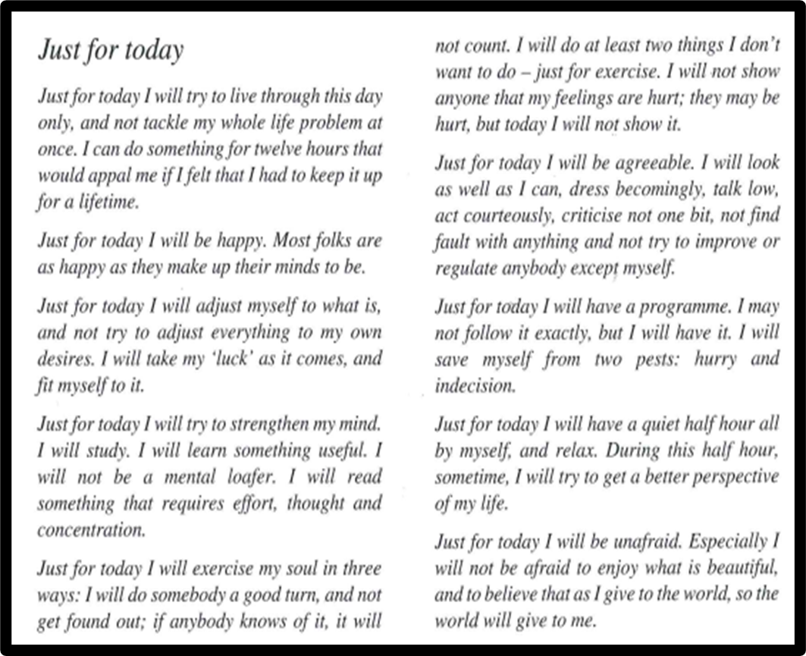

IN CLOSING
(+0.59) Secretary: Thank you <volunteer’s name>
In closing the opinions expressed here today were strictly those of the person who gave them & were spoken in confidence. Take what you like and leave the rest
Anonymity is a core tradition on which the programme depends.

Whatever problems you have, there are those among us who have had them too. If you keep an open mind, you will find help. Let us talk to one another and reason things out but let us not gossip or criticise each other. Instead let the understanding, love and peace of the programme grow in each of us one day at a time.
At this meeting we do not share individuals’ numbers. For outreach or sponsorship, we encourage you to stay on the call after the meeting to speak with the Newcomer Servant, alternatively you can email uk.tuesday.newcomer@gmail.com. For all please stay on the line after the meeting to connect in fellowship.
Will you join me in the closing serenity prayer, and holding hands metaphorically, using the word God as you understand it.
ALL AT WILL: 'God, grant me the serenity to accept the things I cannot change,
Courage to change the things I can,
And wisdom to know the difference.'

ALL AT WILL: Keep coming back, it works if you work it - so work it, you're worth it!
_____________________________________________________________________________________________________
- Group Conscience Serenity Prayer (about + 1:05 if scheduled)
Secretary: Please will you help me open our Group Conscience with the Serenity Prayer, using the word 'God' as you do or do not understand it:
All at will: God, grant me the serenity to accept the things I cannot change, courage to change the things I can and wisdom to know the difference. Opening a Group Conscience (about + 1:06 if scheduled)
Secretary: Welcome! This is the Group Conscience of the UK Tuesday Morning Meeting of Sex Addicts Anonymous.
A Group Conscience is a special decision-making meeting for the group to consider an issue that it is felt requires more time than could be given during the regular meeting. This Group Conscience was called to consider
[describe briefly the reason for the Group Conscience]
Decisions are normally by unanimous agreement, but many meetings also agree to conform to a majority vote if necessary. We have scheduled a maximum of 45 minutes for this Group Conscience. If we have not reached an agreement by 11:15 we can schedule another Group Conscience. In any case I will summarise any decisions and progress made and record them in the meeting notes.

The 12 Traditions (volunteer, about + 1:08 if a Group Conscience is scheduled)
Secretary: Could a volunteer read The Twelve Traditions of Sex Addicts Anonymous
1. Our common welfare should come first; personal recovery depends upon S.A.A. unity.
2. For our group purpose there is but one ultimate authority - a loving God as may be expressed in our group conscience. Our leaders are but trusted servants; they do not govern.
3. The only requirement for membership in S.A.A. is a desire to stop addictive sexual behaviour.
4. Each group should be autonomous except in matters affecting other groups or S.A.A. as a whole.
5. Each group has but one primary purpose - to carry its message to the addict who still suffers.
6. Our fellowship ought never to endorse, finance, or lend its name to any related facility or outside enterprise, lest problems of money, property and prestige divert us from our primary purpose.
7. Each group ought to be fully self-supporting, declining outside contributions.
8. Sex Addicts Anonymous should remain forever non-professional, but our service centres may employ special workers.
9. S.A.A. as such, ought never to be organised; but we may create service boards or committees directly responsible to those they serve.
10. Sex Addicts Anonymous has no opinion on outside issues; hence the S.A.A. name ought never be drawn into public controversy.
11. Our public relations policy is based on attraction rather than promotion; we need always maintain personal anonymity at the level of press, radio, TV and films.
12. Anonymity is the spiritual foundation of all our traditions, ever reminding us to place principles before personalities.
Group Conscience discussion (about + 1:10 if scheduled)
Secretary: The Group Conscience is open for discussion. Please introduce your contributions by your first name and any short description that might be appropriate.
Closing a Group Conscience (by + 1:45 if scheduled)
Secretary:
Either: This Group Conscience has decided [briefly describe the group decision]
or: Unfortunately the group has indicated that this question needs more time but the time scheduled for this Group Conscience is up. Any member may call for another Group Conscience if further discussion is required. We must close now but we have made the following progress [briefly describe progress made]
In any case:
In closing:
The opinions expressed here tonight were strictly those of the person who gave them. Take what you like and leave the rest.
The things that you heard were spoken in confidence and should be treated as confidential. Keep them within the walls of this room and the confines of your mind. Remember that anonymity is a core tradition on which the programme depends.
Whatever problems you have, there are those among us who have had them too. If you keep an open mind, you will find help. Let us talk to one another and reason things out but let us not gossip or criticise each other. Instead let the understanding, love and peace of the programme grow in each of us one day at a time.
Will you join me in the closing serenity prayer, standing and holding hands if you wish, using the word God as you understand it.
All at will: God, grant me the serenity to accept the things I cannot change, courage to change the things I can and wisdom to know the difference.
All at will: Keep coming back, it works if you work it - so work it, you're worth it!

