Script for the Notting Hill Wednesday Mixed 18.45 meeting
(24/2/2021)

Note: Secretary should open the call here about 10 minutes before the start of the call.
IT Host:
Drop in the chat at the beginning of the call:
If anyone needs to call in by phone at any point
Meeting ID: 581319706
Password: 476048
Dial by your location
+44 131 460 1196 (from the UK)
+44 330 088 5830 (from the UK)
+1 253 215 8782 US
+1 301 715 8592 US
+1 312 626 6799 US (Chicago)
+1 346 248 7799 US (Houston)
+1 669 900 6833 US (San Jose)
+1 929 205 6099 US (New York)

At the 7th Tradition

This is the link for the Cashapp if you'd like to donate:
https://cash.app/download
Donations can be made to:
£SAAWedNotHill
Link for donation to UK intergroup
https://saauk.info/en/donate
Contents
Script 1
List of Tools of Recovery 18
Zoom Security Measures 19
In meeting controls 19
Account settings for meetings 23
Group Conscience Minutes 27

Useful links for hosting:
SAA - (Green Book) SAA's basic text - SAA
Tools of Recovery - A Practical Guide for New Members of SAA - SAA

Script

OPENING
Secretary: Good morning. My Name is <Your Name> and I am a sex addict.

Welcome to the Notting Hill Wednesday Mixed 18.45 meeting. This meeting is open to anyone who desires to stop their compulsive sexual behaviours, there are no other requirements.

Please could we check that everyone has introduced themselves to the group before we begin. The greeter will ensure that anyone joining during the meeting introduces themselves to the group. If you are unable to identify yourself verbally please use the chat. If you cannot introduce yourself for the safety of the group you will be removed.

We ask you to keep your video on during the meeting and to remain facing the camera throughout, being mindful that others can see you. If you are unable to have your camera on, we request that you dial in by phone using the number provided in the chat. You can use the “Gallery View” in the upper right-hand corner to see everyone at the same time. Since this meeting is conducted via video connection, we will conduct it like a regular meeting. The video will focus on you after you begin to talk, or if any noise comes from your connection. Please sit close to the microphone, and speak loudly enough, so that all may hear what you have to share. Please mute your line using the button on zoom, if you are not sharing. The Meeting Leader may mute your line if needed, and may change your screen name for you.

Let's open the meeting with a minute’s silence to remember who we are, why we are here and the addicts who still suffer both inside and outside of these rooms.

SAA is a fellowship of men and women who share our experience strength and hope with each other so that we may stop our addictive sexual behaviour and help others to recover from sexual addiction. The only requirement for membership is a desire to stop addictive sexual behaviour.
SAA is self-supporting; is not allied to any sect, denomination, politics, organisation or institution; does not wish to engage in any controversy; neither endorses nor opposes any causes.

Our primary purpose is to stay sexually sober and help other sex addicts to achieve sexual sobriety. Our programme is derived from the Twelve Steps and Twelve Traditions of Alcoholics Anonymous. Although we are not affiliated with AA, however we are Grateful to AA for this gift.

Anonymity is a core tradition on which the programme depends. Let us make this a Safe Meeting to bring the message of Strength Hope and Recovery, focused on the 12 steps and 12 traditions.

Let us now please open the meeting by unmuting your microphones and joining me in saying the Serenity Prayer using the word God as you understand it:

'God, grant me the serenity to accept the things I cannot change, courage to change the things I can, and wisdom to know the difference.’

OUR ADDICTION
Secretary: Please may we have a volunteer to read “Our Addiction”

VOLUNTEER: My name is <First names only>______, and I'm a Sex Addict.
Our addiction (page 3 paragraph 1-2 of SAA green book)
Before coming to Sex Addicts Anonymous, many of us never knew that our problem had a name. All we knew that we couldn’t control our sexual behaviour. For us, sex was a consuming way of life. Although the details of our stories were different, our problem was the same. We were addicted to sexual behaviours that we returned to over and over, despite the consequences.

Sex addiction is a disease affecting the mind, body and spirit. It is progressive with the behaviour and its consequences usually becoming more severe over time. We experience it as a compulsion, which is an urge that is stronger than our will to resist, and as obsession, which is a mental preoccupation with sexual behaviour and fantasies. In SAA, we have come to call our addictive sexual behaviour “acting out”.

OUR PROGRAMME
Secretary: Please may we have a volunteer to read “Our Programme”

VOLUNTEER: My name is <First names only>______, and I'm a Sex Addict.

Our programme (page 20 of SAA green book)
“Attending SAA meetings starts us on a new way of life. But while the SAA fellowship supports our recovery, the actual work of recovery is described in the Twelve Steps. Meetings are forums for learning how to integrate the steps into our lives. Working the Twelve Steps leads to a spiritual transformation that results in sustainable relief from our addiction.

When we start attending meetings of Sex Addicts Anonymous, many of us are surprised to meet people who are enjoying life, experiencing freedom from the painful, compulsive behaviours that had brought them to SAA. Listening to other members share about their recovery, we gradually realize that in order to make the same kind of progress, we need to be willing to do whatever it takes to get sexually abstinent, and to stay abstinent. We have learned from hard experience that we cannot achieve and maintain abstinence if we aren’t willing to change our way of life. But if we can honestly face our problems, and are willing to change, the Twelve Steps of SAA will lead to an awakening that allows us to live a new way of life according to spiritual principles. Taking these steps allows fundamental change to occur in our lives. They are the foundation of our recovery.”

THE 12 STEPS
Secretary: Thank you <volunteer’s name> Please may we have a volunteer to read the “The 12 Steps”

VOLUNTEER: My name is <First names only>______, and I'm a Sex Addict.

The 12 Steps (pg 20 SAA green book)
These steps are our program. They contain a depth that we could hardly have guessed when we started.
- We admitted we were powerless over addictive sexual behaviour - that our lives had become unmanageable.
- Came to believe that a power greater than ourselves could restore us to sanity.
- Made a decision to turn our will and our lives over to the care of God, as we understood God.
- Made a fearless and searching moral inventory of ourselves.
- Admitted to God, to ourselves, and to another human being the exact nature of our wrongs.
- Were entirely ready to have God remove all these defects of character.
- Humbly asked God to remove all our shortcomings.
- Made a list of all persons we had harmed and became willing to make amends to them all.
- Made direct amends to all such people wherever possible, except when to do so would injure them or others.
- Continued to take personal inventory, and when we were wrong promptly admitted it.
- Sought through prayer and meditation to improve our conscious contact with God as we understood God, praying only for knowledge of His will for us and the power to carry that out.
- Having had a spiritual awakening as a result of these steps, we tried to carry this message to other sex addicts and to practice these principles in all areas of our lives.

Many of us exclaimed, "What an order! I can't go through with it." Do not be discouraged. No one among us has been able to maintain anything like perfect adherence to these principles. We are not saints. The point is that we are willing to grow along spiritual lines. The principles we have set down are guides to progress. We claim spiritual progress rather than spiritual perfection.
ABSTINENCE IN SAA
Secretary:
“Our goal when entering the SAA program is abstinence from one or more specific sexual behaviours. But unlike programs for recovering alcoholics or drug addicts, Sex Addicts Anonymous does not have a universal definition of abstinence. Most of us have no desire to stop being sexual altogether. It is not sex in and of itself that causes us problems, but the addiction to certain sexual behaviours. In SAA we will be better able to determine what behaviour is addictive and what is healthy. However, the fellowship does not dictate to its members what is and isn’t addictive sexual behaviour. Instead we have found that it is necessary for each member to define his or her own abstinence.

We are individuals, and our addictive behaviours, while similar, are unique to us. What may be healthy for one member could be clearly addictive for another. SAA simply cannot predict every possible way of acting out and define them all for everyone. As a fellowship, we wouldn’t want to deny that any particular behaviour might be acting out for a member. Nor would we want to restrict behaviours that are healthy for some of us. Since different addicts suffer from different behaviours, and since our sexuality is experienced in so many different ways, it is necessary that SAA members define for themselves, with the help of their sponsors or others in recovery, which of their sexual behaviours they consider to be ‘acting out.’”

NEWCOMERS INTRODUCTION

Secretary: Are there any newcomers on the call today?
If yes…
Secretary: Please may we have a volunteer to read the “A letter to newcomers”

VOLUNTEER: My name is <First names only>______, and I'm a Sex Addict.

Dear < Newcomers names >
Welcome to S.A.A.. When we came to our first meeting many of us were having a variety of feelings. We were relieved to have found a place where our pain and despair might be understood. We were angry that we had to get help and couldn’t manage this part of our lives. We felt lonely and were ashamed of our sexual history. We had secrets that we were reluctant to share. We were distrustful, guarded and frightened. We had been abused and we had abused others. We were sex addicts and needed help.
The programme of S.A.A. is patterned after the Twelve Step Programme of Alcoholics Anonymous. Here we learn a new way of living. We learn, at our own pace, to experience intimacy and sharing with others in a healthy way. We learn to trust; to express our feelings; to ask for our needs to be met; to say no when no is appropriate; and to stay around when all we want to do is run. Here no one shames us for what we have done or are still doing. Here we have a safe harbour within which to heal, and for that we are grateful.
The only requirement for membership in S.A.A. is a desire to stop compulsive sexual behaviours. It is a programme of progress, not perfection. If you are willing to be honest and have a desire to have and maintain healthy relationships, then you are in the right place.
It is suggested that you attend at least six meetings before you decide whether the programme is for you. At your first meeting we encourage you to talk to others and exchange telephone numbers with those you relate to. We also suggest that you select a temporary sponsor to assist you in learning the basics. The selection process is easy: all you do is ask someone you relate to (to whom you are not sexually attracted) if they would be willing to be your temporary sponsor until you learn your way around. At a later date, after you have got to know us better, we suggest you choose a permanent sponsor.
You can read about sex addiction and recovery in the pamphlets at saa-recovery.org or in the following books:
- Sex Addicts Anonymous (SAA “Green Book”)
- Hope And Recovery by Hazelden Publishing
- Out of the Shadows by Patrick Carnes
- Don’t Call It Love by Patrick Carnes
- Alcoholics Anonymous (AA “Big Book")
- Twelve Steps and Twelve Traditions (AA “Twelve and Twelve”)

The SAA Green Book can be accessed online through the SAA website (saa-recovery.org). The other books are available in most major bookstores, either new or used.

We are happy that you are here, for it is the newcomer that keeps S.A.A. alive and well. We encourage you to take it ONE DAY AT A TIME, BE GENTLE WITH YOURSELF, and KEEP COMING BACK.
GROUP INTRODUCTIONS
Secretary: We now go down the list of participants and do group introductions, saying our first names, our bottom-line addictive behaviours, what we’re feeling today and how long we’ve been sober. Please be brief, as there will be time for general sharing later in the meeting.

READING AND MEDITATION
Secretary: Now we have today’s reading from Answers in The Heart, followed by 5(?) minutes meditation.

Secretary: Please may we have a volunteer to be timekeeper?
Secretary: Please may we have a volunteer to read today’s reading from Answers in The Heart?

After 5 minutes.

FOCUS
Secretary: We now come to the focus of today’s meeting. In this meeting we read a chapter from the Green book in week 1, a selection of the tools of recovery in week 2, a tradition from the Green book in week 3, we have a chair in week 4, and share our experience of 3 recovery topics chosen by participants in week 5.
This being the <x^{th} week of the month > the focus is:
Week 4: Guest Chair Speaker shares on a topic of his\her choice.
Chairperson decides length of share.
Secretary: Introduce a Chair speaker
“Today I would like to introduce today’s guest Chair Speaker: ‘myself’ OR ‘________’, who has come to share their experience, strength and hope with us for 10 - 15 minutes.” (Normally for 15 mins)
After 15 minutes
(After the reading or chair has finished)
Secretary: I will now ask people to come in and share. A share is an experience that has helped us to grow and has given us a new sense of awareness. We encourage your share on today’s meeting focus. Please share on your Experience Strength & Hope encountered in recovery and the 12 Steps and 12 Traditions. Please bear in mind tradition five, ‘each group has but one primary purpose - to carry its message to the sex addict who still suffers.
In your sharing, please be sensitive to the safety of others by avoiding overly specific descriptions of acting out behaviours, naming specific places you have acted out in or publications, broadcasts and services you have used and avoid using slang terms for acting out behaviour.
We do not interrupt each other, and we do not ask questions or engage in discussion, Please speak in “I” Statements not “You” or “We” statements to avoid sounding like you are giving advice. Be aware that the secretary may intervene in the unlikely event of an inappropriate share.
Although anonymity is a core tradition, you should be aware that some people may decide, after careful thought, to report certain disclosures to the authorities. We use only our first names. Whatever our status or position outside of this group is not an issue here.

Our group conscience decision suggests that, when asked to share, speakers refrain from reference to non-SAA literature, authors or counsellors by name. Speakers will share for __2__ minutes with an additional minute to wind-up.
(To timekeeper) Would you be happy to carry on keeping time and let speakers know their time is running out at 2.5 minutes?
(Secretary invites people to share until 20.05)

AT 20.05

If anyone didn’t get a chance to share, stay for fellowship and there will be another opportunity to share.

7th Tradition

Secretary: Now is time for the 7th tradition.

As a reminder on the 7th Tradition. The Seventh Tradition states that "every group ought to be fully self-supporting, declining outside contributions." 12-step meetings around the world pass a basket to receive donations that are used to support recovery. Because that activity is not possible in our telemeeting, we would encourage you to consider making a donation to this Notting Hill meeting via the CashApp and the link to use will be shared in the chat and on the meeting Whatsapp group. Alternatively, we suggest that you can make a contribution to the UK Intergroup. Those web addresses are listed in the meeting script which can be downloaded from our webpage. Your donation will help all of us in our recovery.
After the meeting, the parking lot will be open for anyone who has a question about the program or just wants to continue fellowship. To enter the parking lot all you have to do is stay on the line. The parking lot will remain open as long as there are two callers on the line.

ANNOUNCEMENTS
Secretary: In this meeting we hold a group conscience to find solutions to the group’s needs on the first Wednesday of the month, immediately after the main meeting is closed. Any items to be added to the group conscience can be shared with the secretary in the chat.

Are there any other announcements for the good of the fellowship?
(After announcements are complete)

MEETING WHATSAPP GROUP
Secretary: There is a Whatsapp group for this meeting. The contact number to message if you would like to join the group will be shared in the chat during fellowship after the closing.

Milestones in recovery
Secretary: In this meeting we celebrate periods of sobriety and time away from our bottom line addictive behaviours.

Is anyone celebrating any milestones in recovery?
Multiple years, 12 months, 6 months, 3 months, 2 months, 1 month, and last but not least 1 day?
SPONSORING
Secretary: Is there anyone available to sponsor?

Secretary: Please could all those willing to call fellows let others know in the chat?

Secretary: I would like to thank those who do service in this meeting:
Co-secretary; Greeter; Host; GSR

THE PROMISES

Secretary: Please may we have a volunteer to read the “The Promises”

VOLUNTEER: My name is <First names only>______, and I'm a Sex Addict.

If we are painstaking about this phase of our development, we will be amazed before we are half-way through. We are going to know a new freedom and a new happiness. We will not regret the past nor wish to shut the door on it. We will comprehend the word serenity and we will know peace. No matter how far down the scale we have gone, we see how our experience can benefit others. That feeling of uselessness and self–pity will disappear. We will lose interest in selfish things and gain interest in our fellows. Self–seeking will slip away. Our whole attitude and outlook upon life will change. Fear of people and of economic insecurity will leave us. We will intuitively know how to handle situations which used to baffle us. We will suddenly realize that God is doing for us what we could not do for ourselves.

Are these extravagant promises? WE THINK NOT!

They are being fulfilled among us, sometimes quickly, sometimes slowly. They will always materialize if we work for them.

THE CLOSING
“This is how recovery has been for us. Each of us has taken steps of courage and leaps of faith. Each of us has contributed, not only to our own recovery, but to the recovery of other suffering sex addicts as well. We have contributed by showing up at meetings and by sharing our experience, strength, and hope. We have listened to our fellow addicts and supported them in their recovery journey. Like the first members of our fellowship, we continue to remain sexually sober by helping our fellow addict stay sober. Our prayer is that every sex addict who seeks recovery will have the opportunity to find it. And keep coming back.”

Let’s close with the Serenity Prayer:

'God, grant me the serenity to accept the things I cannot change, courage to change the things I can, and wisdom to know the difference.
Keep coming back it works if you work it, your worth it.’

Thank you for allowing me to be of service and I wish everyone a safe, sane, and sober night.

END

******************************************************************

7th Tradition donation websites:
Donation to the UK Intergroup can be made at saauk.info/donate or the Telemeeting Intergroup at saatalk.org or ISO Intergroup at saa-store.org/7thTradition

List of Tools of Recovery
The Twelve Steps (pg2)
Sponsorship (pg3)
Attending meetings
Literature
The three circles
Getting honest about the middle circle (pg7)
Using the telephone
First step presentation
One day at a time (pg9)
Fellowship
Friendship (pg10)
Changing old routines
Living through discomfort of withdrawal
Prayer (pg12)
Defining the God of our understanding
Let go and let God
Meditation (pg15)
Writing
Book ending (pg17)
HALT
Three second rule
Looking at consequences
Thinking a slip all the way through
Letting go of old ideas (pg21)
Rigorous honesty
Identify – don’t compare
Progress not perfection (pg23)
Easy does it
Live and let live (pg24)
Asking questions
Feedback
Outside resources (pg26)
Three things a day
Handling travel (pg27)
Being positive
Outer circle activities
Getting some exercise (pg29)
Service

************************************

Zoom Security Measures
To minimise disruptive behaviour, this meeting currently has the following security measures selected from the recommendations here and outlined below:

In meeting controls
On opening the meeting
This meeting has a host and greeter to manage the technology and participants. On initiating the meeting the following need to be actioned:
- The greeter provided with co-host privileges
- Chat settings changed to ‘Participants can chat to: host only’
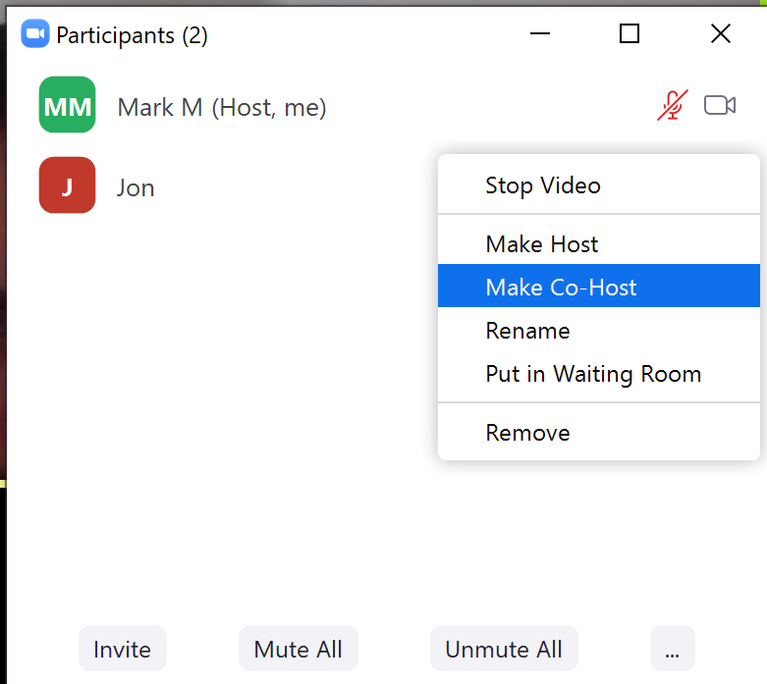

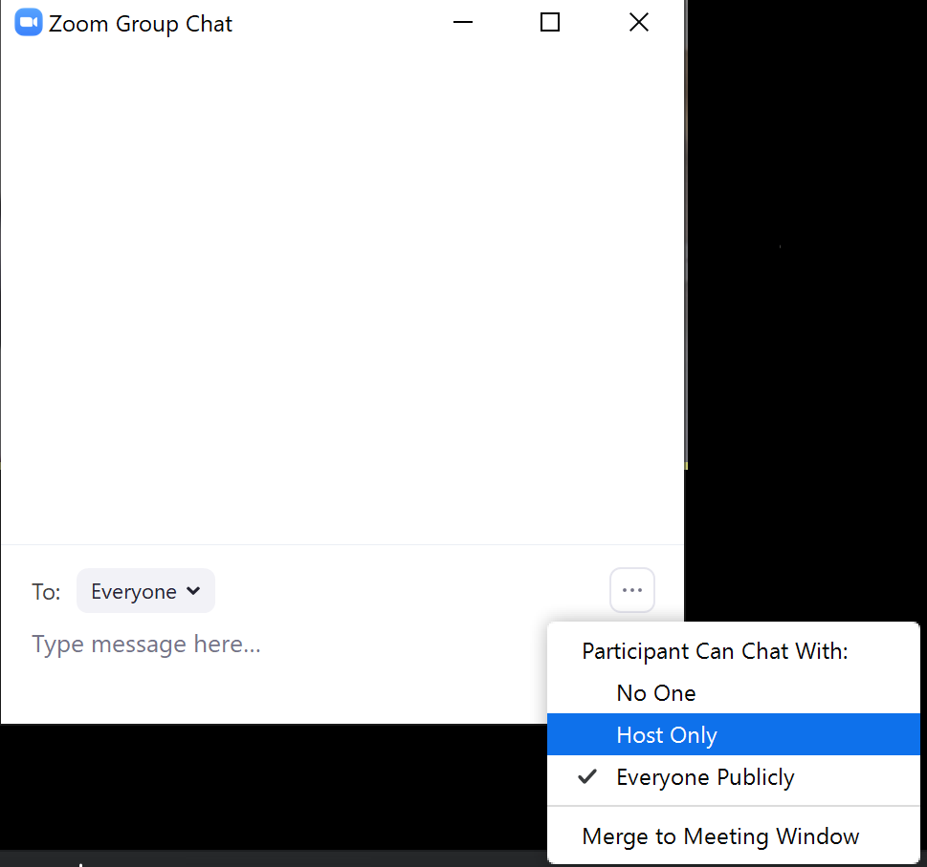

During the Meeting
The waiting room is enabled and the host or greeter (provided with co-host privileges) should:
- Have open both the ‘Manage Participants’ window throughout the call and monitor any new arrivals in the waiting room
- Promptly admit or remove those in the waiting room
- Using the chat or audio greet each unknown arrival
- If necessary rename the participant using their first name
- Remove any participants who are being disruptive
  - Participants removed will not be able to join the meeting again that week (Zoom blocks them)

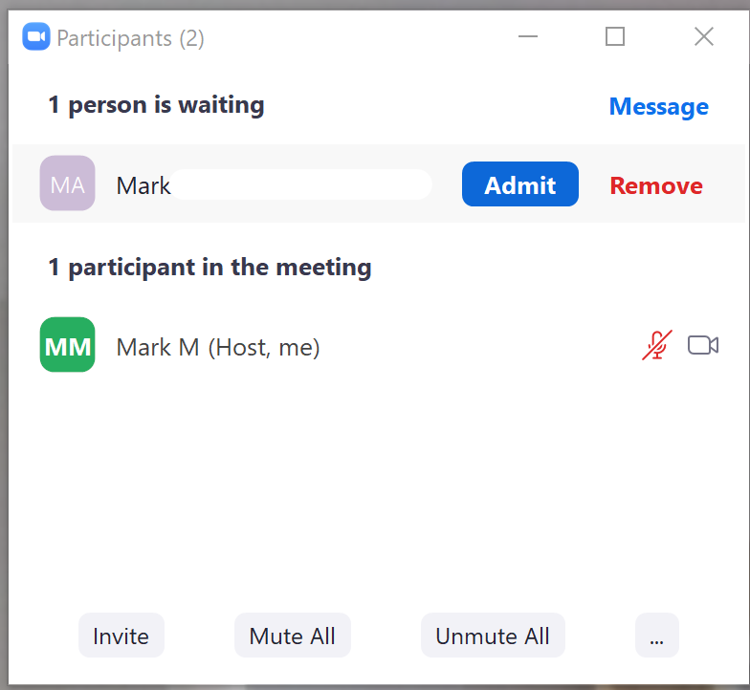
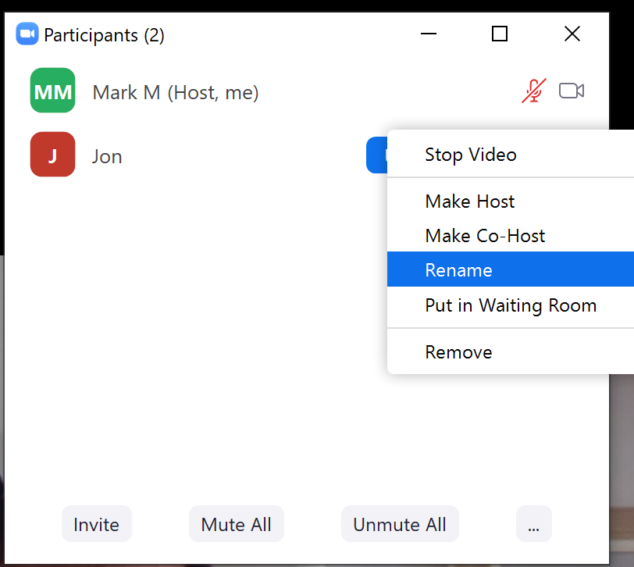 | 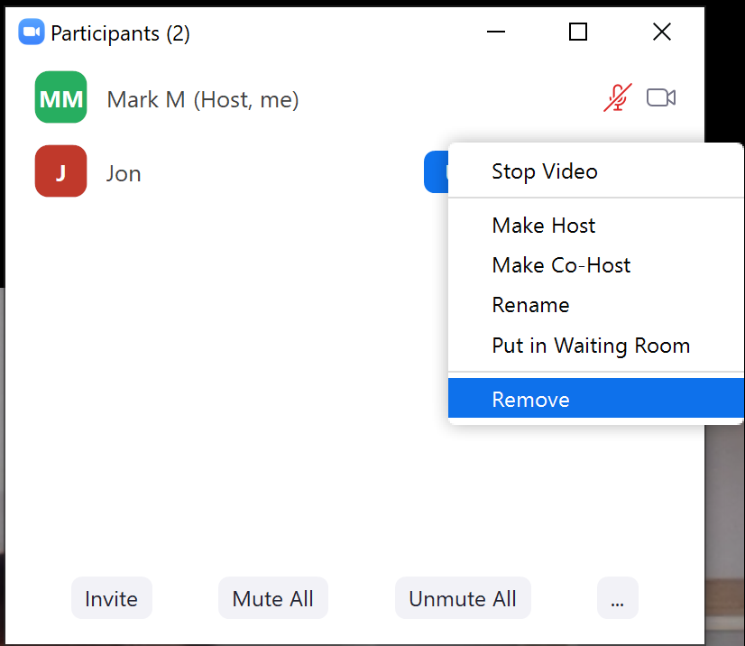

Account settings for meetings
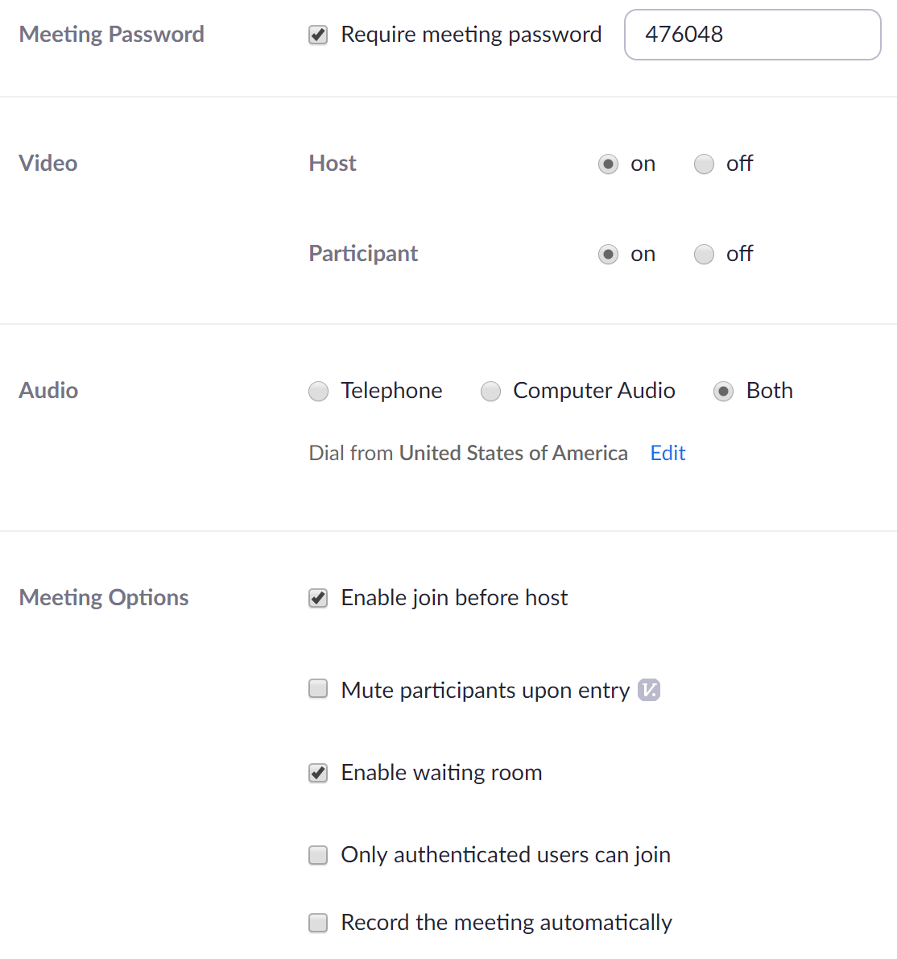

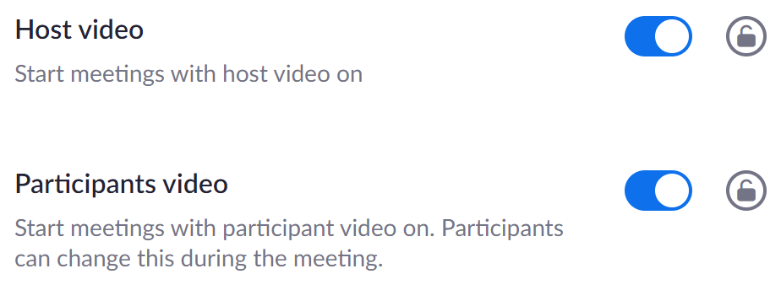
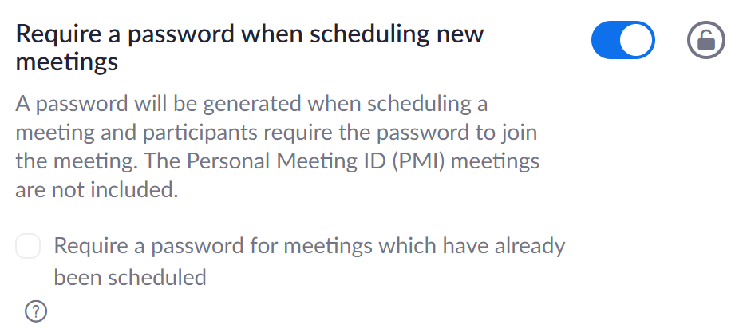
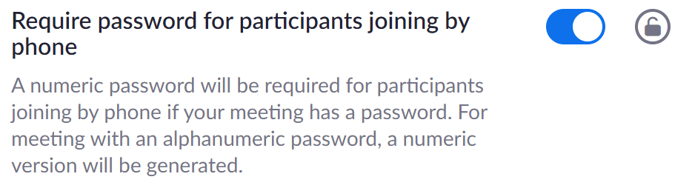
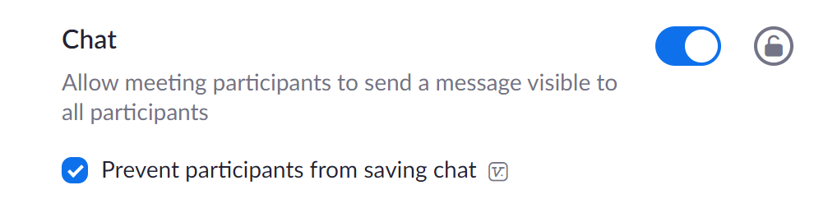
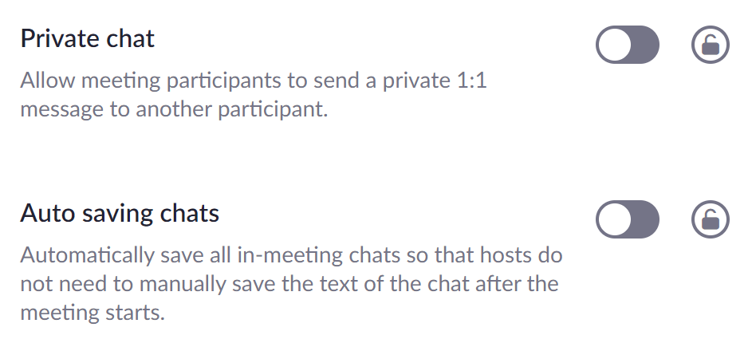
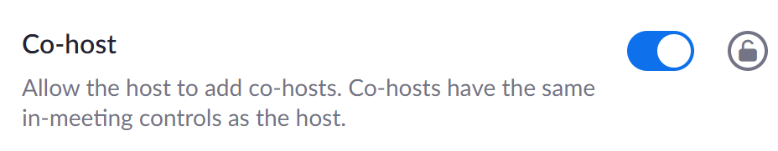
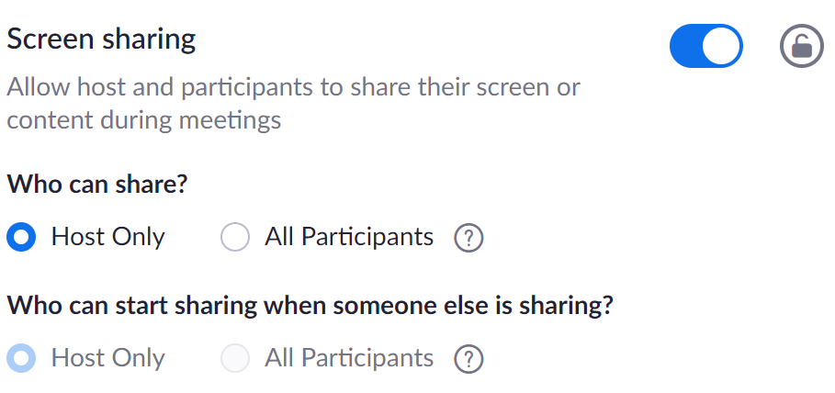
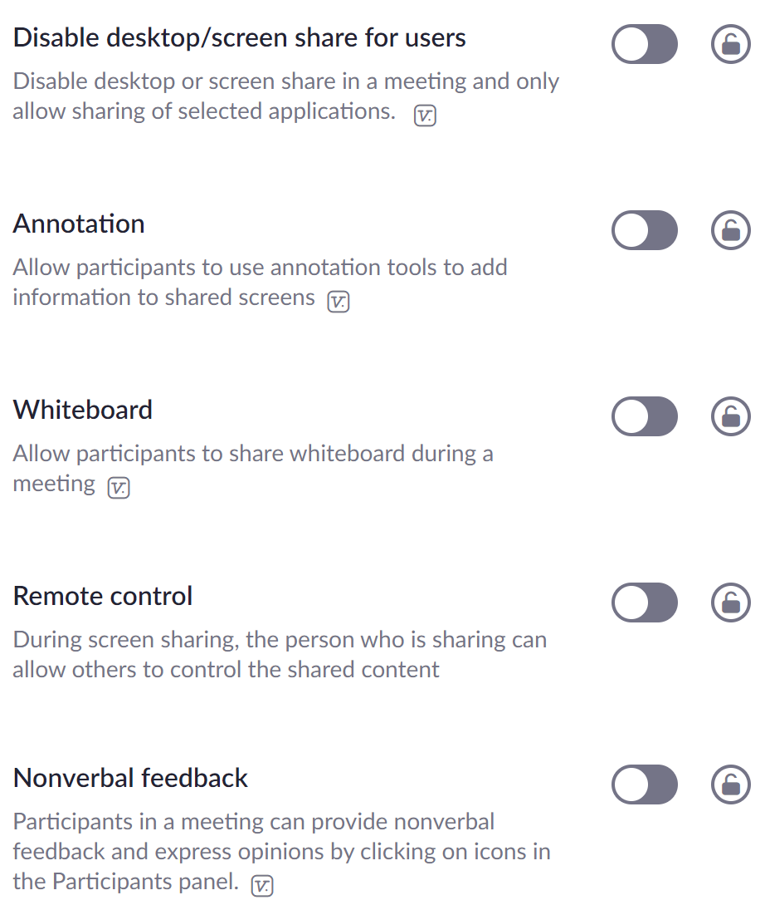
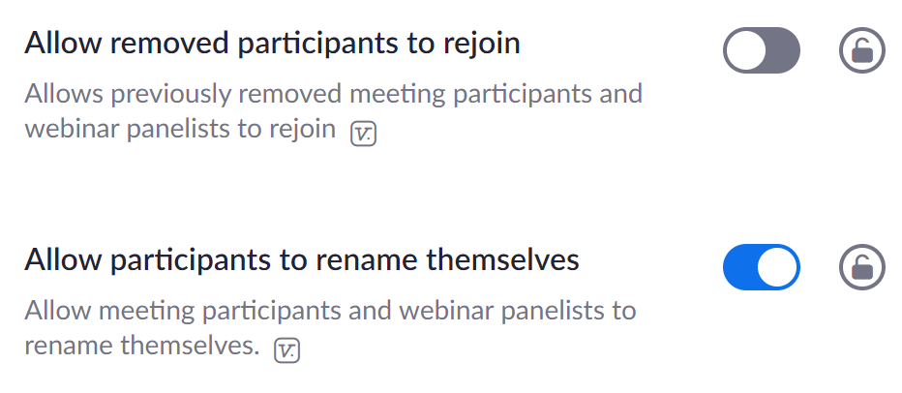
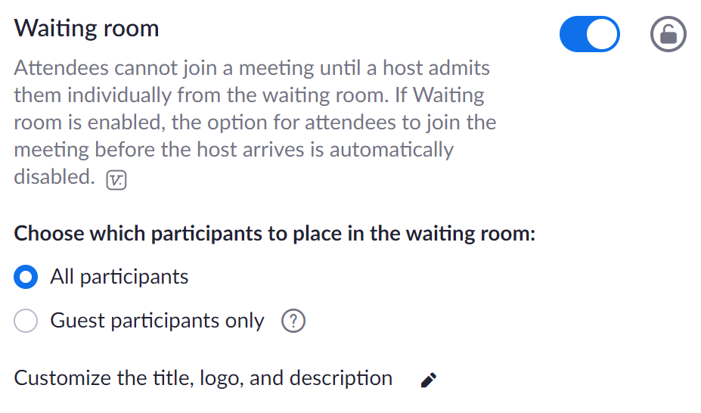
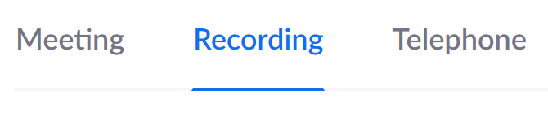
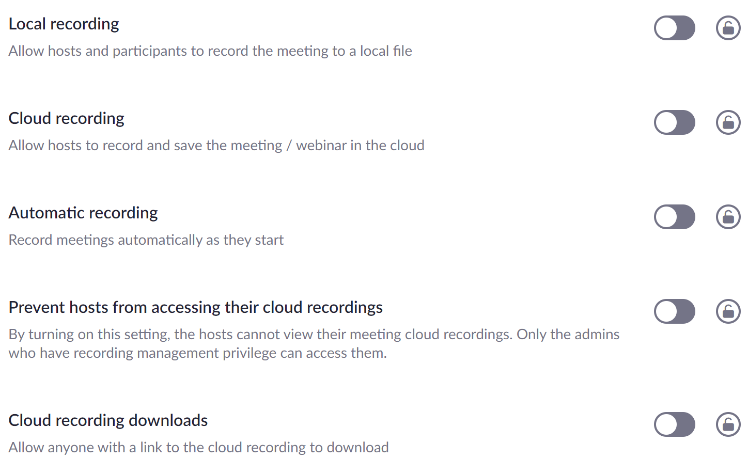
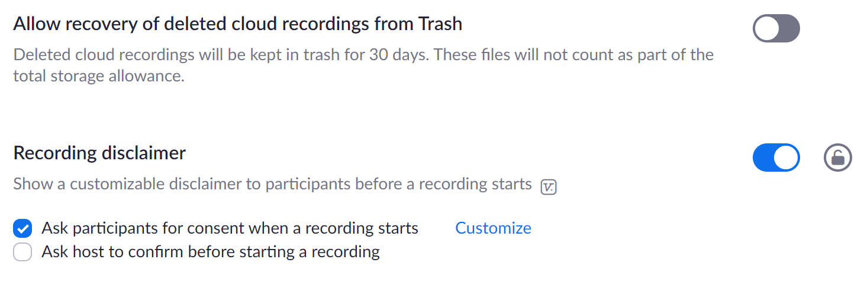

Group Conscience Minutes
First week of April
Confirmation of roles
Fixed roles:
Role | Requirements | Person in role
Co-secretary | 1 month sobriety on taking the role, have finished step 5 | Ken and Mani
Treasurer | Liquidity, considers home group | Anthony
Greeter + eliterature  (Greeter, including newcomer welcome and sharing literature links) | Willing to commit to regular attendance | Tom S
Host / IT support | Willing to commit to regular attendance | Rota with those willing (Ken, Mani, Mark)
GSR  3 months sobriety  Attend 2 intergroup meetings and manage emails and newcomer piece, with password. | Have a sponsor, sobriety requirement of 1 month, have done the steps at least once | Mark

Roles on the day:
Time-keeper

Payment of the Zoom meetings
- For monthly payment, rotate on payment
- For next month set-up a generic email and link it to zoom to better share the hosting
- Kevin to provide update on finances and then use the reserve before rotating the contributions for subscription
First week of May
Agenda items:
- Co-secretary role is open
  - Mani is going to be co-secretary while we’re on Zoom
- Zoom payment of GBP 11
  - 7th traditions can be paid through SAA website
  - Paypal option for contributing to the running cost of this specific meeting
- Church contribution of say 50% of meeting cost to support running costs of the church as a good will gesture
- Host / IT support – Mark M voted in

- Paypal – could Kev set-up a paypal for transfers or Nathan would receive it and then transfer?

  - Nathan to reach-out to Kev and agree way forward.
- Agree costs the group will pay and track in a budget
  - GBP 2.50 per week
  - Donation of x amount per week

- Chair finder
10th June announcement from Kevin and Nathan
- We haven’t found a way that the Paypal account can be created anonymously
- Nathan confirmed that the church aren’t in need of funds at this time
- Only literature from the programme
- Sharing written gratitude lists
- Appropriate language (no swearing etc…)
1st July
- CashApp is functioning and Zoom is being paid from the pooled funds
- Ask Nathan if he is willing to check with the church on when we could go back to a (parallel?) face-to-face meeting and what the maximum number of people are
- Added the text to the script:
  - Please be mindful of the fact that you are on camera and others can see you. If you are unable to have your camera on, we request that you dial in by phone using the number provided in the chat.
- Find some text that we can use in the script along the lines of: cursing / swearing, specific sexual acts, body parts and names of people or places
- Minimum of 3-minute shares
- Maximum 3 tools in the tools week
Group conscience topics
- Is the script fit for purpose?
- Reminders: cross-talk, can be put into the chat
  - People who are known will not be removed if they aren’t showing the video
- In the previous meeting if they were new then they were asked to log in early.
  - Process mute-all, kick them out
  - General email came out to all groups that there was a request that people contact by email and make contact
  - Rotate IT hosting
  - The role of the GSR is to manage the group conscience and run the website etc… Kev to share
  - Service roles updated
  - As GSR need to get hold of Nathan

Group conscience 7th October
- Vote was confirmed to continue with the hybrid meeting
- Mask as optional and not mandatory and it’s a big enough space for social distancing. If anything comes up then Nathan will flag.
- Rent has been negotiated to be a donation.
- [Zoom is the default connection unless anyone person present at the beginning of the physical meeting objects, in which case we will switch to the phone connection.] – potentially unimportant as people can sit off screen
- Physical meeting organiser / opener – Nathan

6th Nov Group Conscience
- For follow-up with Anthony on finances
  - Back-Payment to Mark for Zoom costs as previously agreed
  - GBP 10 for each week that we’ve been here so long as there’s money in the kitty
  - Anthony to transfer the rest to inter-group
Jan group conscience
- GBP 625 funds in cash app
- After prudent reserve of GBP 120 transfer balance to intergroup
  - Nathan will let Anthony know the balance to be paid to the priest at GBP 10 per week
- 1 minute warning is disruptive give the warning at 2.5 minutes
  - No 1 minute warning only a warning at 2.5
For the next Feb group conscience
- Changes to script for Zoom – didn’t upload the latest version, need to postpone
- Video on as obligatory wasn’t passed
  - Decision made: Update website with request for video or phone in lifted from script initially
- Decision made: moment of silence at the beginning of the meeting to be a minute

